Cloud Computing Fundamentals

Cloud Gaming Flowchart

Name: Aryan Saxena

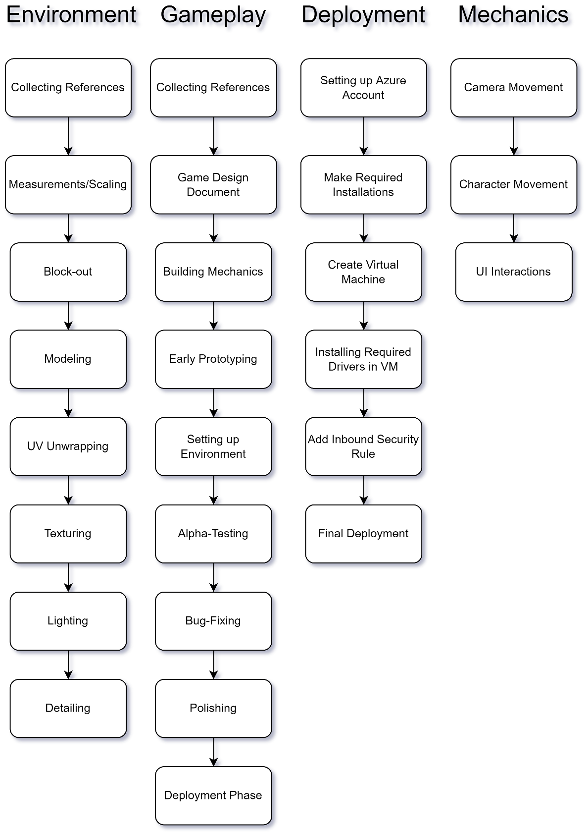SAP: 500082431  
Roll No.: R214220274

As the concept of metaverse expands, need for high-fidelity web-based gaming applications keeps on increasing. On the down side, current generations on web-browsers is not capable for rendering high fidelity graphics in real-time.   
This problem is solved by Azure Cloud Gaming, where Virtual Machines are used for Pixel Streaming. With Pixel Streaming, any computer with good internet connectivity can experience high-fidelity metaverse interactions through web.